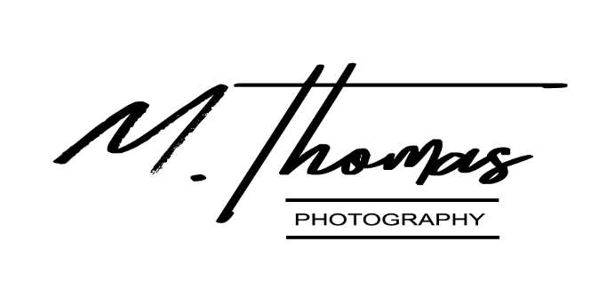

I hereby assign M. Thomas Photography the irrevocable and unrestricted right to use the photographs listed below of myself, said listed model. Listed said images may be used for printing, editorial, advertising, marketing, education, social media, M. Thomas Photography’s website and any other purpose and manner and medium; to alter the same without restrictions; and to copyright the same without restriction. The model listed releases all claims to profits that may arise from use of said images.
The photographs listed and produced by M. Thomas Photography are protected by Federal Copyright Law (all rights reserved) and may not be used in any personal manner outside of what was agreed upon by M. Thomas Photography and ________________________, which will hereafter be known as the Client. I agree that the Client may use said listed images for reproduction in the use of their advertising, marketing, social media, and furthering their brand. I understand that said images are not the property of said listed model and that if at any time said listed model was to leave the employment of the Client any and all use of the said images by the said model is to be terminated for any personal or professional use.

IMAGES CHOSEN ON DAY OF PHOTO SHOOT: _______________________________________________

_______________________________ PRINT NAME

_______________________________ SIGNATURE

